 |  | RPS Landscape Group Members’ Exhibition 2025/26  Submission Form | 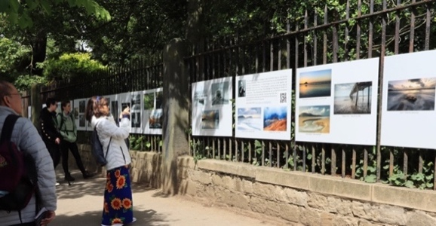

Following our successful Exhibition in 2022/3, we are planning a 2025/6 series at more locations. The exhibition is open for submissions from 10th October for Landscape Group Members to use this form, with up to 2 images, using WeTransfer (note 3) to Landscape25Submissions@RPS.org, no later than 23:59 GMT on 7th November 2024.

Form Name: |  | Rename this form with your name – e.g. “LSIG Exh25 Submission-Jane Smith LRPS”
Name / RPS number: | / #
RPS Region |  | If International, please state your Country
Your Email Address:
Your Website or Social Media page |  | Choose a link your website or one social media account: X, Facebook or Instagram
Image 1 |  | Images must be named “Title by Your Name”
Image 2 (Optional) |  | e.g. “Brighton Beach by Jane Smith LRPS”

- Images must have been taken since 1st January 2022. Landscape is defined as: all elements of the land, mountains, hills, farmland, the coast, bodies of water, urban & rural environments, under varying lighting & weather conditions, in both traditional & abstract forms. We are seeking a variety of high-quality images including: Colour, Mono, InfraRed, ICM, Multiple Exposures, etc; including Square, Portrait & Pano.
- Submitted images should be in JPEG format, in sRGB, with no logos/text; 5000px on the longest edge (4000px for square format).
- You must change the WeTransfer default of 3 days to 7 days - click the ellipsis (…) & select 7 days.
- To avoid the disappointment of members not being able to make a submission by the deadline date, we have changed the selection process (e.g. no early cut-off). A small Selection Team will select the images. No member will have more than one image selected. You will hear the result from us by 9th December 2024.
- Our Online Gallery will include a link to your website (if you have one), but there is a new alternative: linking to one of your social media accounts instead.
- We intend to produce a catalogue of the exhibition, to be sent to those with an image in the exhibition, at no extra charge. Additional copies may be available for a nominal charge.
- The Landscape Group cannot cover the full cost of holding this multi-location exhibition. There is a nominal £30 fee for each selected image, payable post-selection. The Landscape Group will fund the remaining costs.

Terms & Conditions
- We are unable to accept submissions by email. The WeTransfer confirmation of our downloading is your receipt - If not received within 96 hours of submitting, please email Landscape25Submissions@RPS.org.
- By submitting this form, you commit to paying a contribution towards the exhibition of £30 if selected.
- Our confirmation of selection will give payment details, with a payment deadline of 19th December 2024. We may offer your image’s exhibition space to another member if you fail to make the payment.
- If you are unable to meet a December deadline (e.g. on vacation), please advise us by 30th November 2024.
- The above fee is non-refundable, unless the exhibition is cancelled before significant costs are incurred.
- RPS insurance covers 3rd party liability but not the exhibition itself; we cannot refund members in the event of damage or theft. We may attempt to repair a damaged panel (not reprint it) or withdraw it from display.
- Selected images may be used in exhibition promotion, or otherwise relevant to the exhibition.

Please Leave Blank | Received: |  | Reference:

