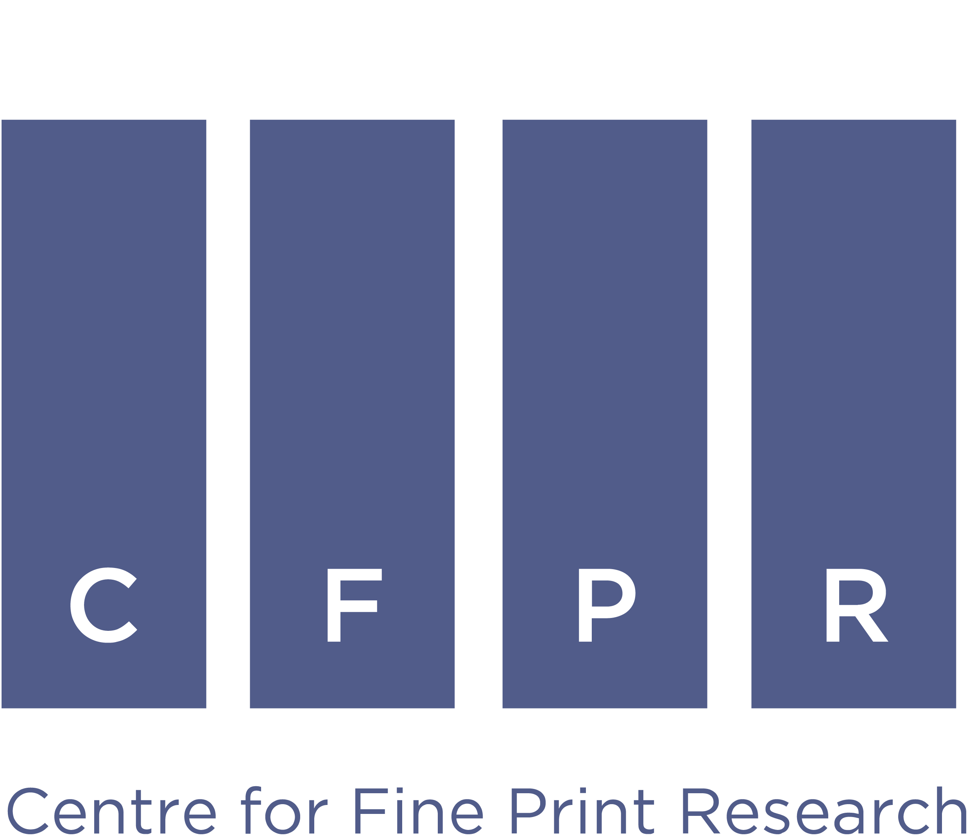
Don't Press Print - the collodion process: online conference
Online: 1 and 2 October 2020
The draft conference programme and paper titles are below. We aim to ensure that timings are adhered to so that registrants, particularly those outside of the UK and Europe, can join when convenient. Although we are not expecting any significant changes it is subject to amendment. If you have any questions please email: director@rps.org
Dr Michael Pritchard Frank Menger
The Royal Photographic Society CFPR, University of the West of England

Draft programme
Thursday, 1 October 2020
(timings are British Summer Time) / GMT -1 / EST -5 / PST -8 / Sydney +9 / Tokyo +8 / IST +4½)
0930-1000 | Introduction: Dr Michael Pritchard (RPS) and Frank Menger (CFPR/UWE)
1000-1025 | KEYNOTE: Mark Osterman / Collodion as a Medium
1030-1055 | Adrienne Lundgren and Rachel Wetzel / Archer with a Shelf-Life: Dry Plate Collodion and Its Use in the United States
1100-1125 | Ashleigh Black / Lights and Shadows of Nature Reversed - George Washington Wilson’s Guide to the Collodion Process
1130-1155 | Zsuzsanna Szegedy-Maszak / The Recently Discovered Notebook of Miklós Barabás  A Case Study of How Photographers in Eastern Europe Acquired Information on the Wet-Collodion Process
1200-1225 | Tony Richards / The Digitype and the Inter-positive. A new Collodion narrative.
1230-1300 | Panel discussion / Q+A
1300-1400 | Break
1400-1425 | Ian Chamberlain / Altered states; The use Collodion as part of an inter-disciplinary approach
1430-1455 | Chihoko Ando / Foreseeing the Future; Ambrotype Portrait Photos as a Symbol of Life and Death in the 19th Century Japan
1500-1525 | Shreya Mukherjee / Rebirth of the Picture-perfect Collodion: The New Indian Story
1530-1555 | Bill Nieberding / A Withering Gaze: Technical Excellence and Aura in Contemporary Wet-collodion Photography
1600-1625 | Alan Hodgson / The collodion halftone process 1895 - a technical appraisal
1630-1745 | Panel discussion / Q+A
1745-1800 | Day 1: Closing remarks / online social gathering

Friday, 2 October 2020
(timings are British Summer Time) / GMT -1 / EST -5 / PST -8 / Sydney +9 / Tokyo +8 / IST +4½)
0930-1000 | Introduction: Dr Michael Pritchard (RPS) and Frank Menger (CFPR/UWE)
1000-1025 | KEYNOTE: France Scully Osterman / Crossing Paths
1030-1055 | Erin Solomon / The Chemistry of Trauma: Practical Research inspired by photographs from the American Civil War
1100-1125 | Rob Ball / Dreamlands: Tintypes at the Edge
1130-1155 | Paul Elter / Travel and the Mobile Darkroom-from the beginning of wetplate to contemporary art practice.
1200-1225 | Christian Klant / Wet Plate Collodion Then and Now - Observations of a practitioner
1230-1300 | Panel discussion / Q+A
1300-1400 | Break
1400-1425 | Adrian Cook / Subject advised, but awaiting title
1430-1455 | Steve de Grys / Subject advised, but awaiting title
1500-1525 | Niamh Fahy / Interpreting Interruption
1530-1555 | Wilson Yeung / Paleontology Guide: Images-Objects-Being
1600-1625 | Jo Gane / Contemporary Practice with Wet Collodion : Time-travel and Public engagement through the performance of processes
1630-1745 | Panel discussion / Q+A
1745-1800 | Day 2: Closing remarks / online social gathering

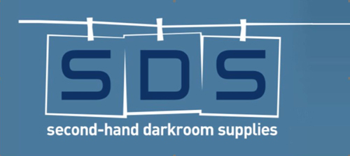
Titles will be updated when received.
Supported by:
Delegates will receive a short abstract of each paper, together with a short biography and institutional affiliation of the presenter before the conference.

