WOMEN, PHOTOGRAPHY and POLITICS
FEMALE MPs PHOTOGRAPHED BY ROYAL PHOTOGRAPHIC SOCIETY (RPS) WOMEN IN PHOTOGRAPHY
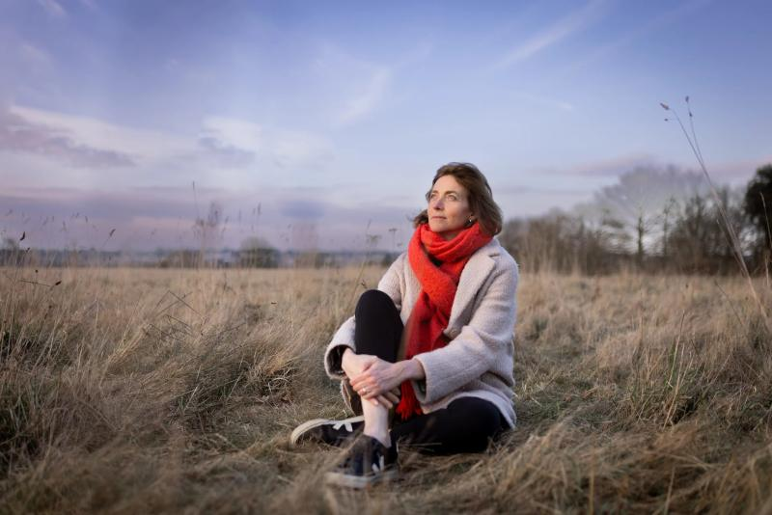
A WOMEN-LED photography project will celebrate the record-breaking 264 women MPs in Parliament who are representing people across the UK.
The Royal Photographic Society’s (RPS) Women in Photography (WIP) group has launched the 40% Project, a portrait initiative that matches women photographers with MPs to visually honour this inspiring milestone.
Sue Wright, Chair of the RPS WIP group, said: “As a result of the 2024 General Election, we now have the highest number of women MPs in Parliament”.
“We plan to record the strength, grace, and power of these women through the talents of female and female-identifying photographers, by capturing the essence of their leadership through photography.”
The WIP group initially offered the opportunity to its group members, with more than half of the MPs now taking part and being photographed. There will also be a call-out to other women photographers via colleges, universities, and other women-led photographic organisations to create portraits with the remaining politicians.
Photographer Eleanor Church worked with Colchester’s first woman MP and the city’s first Labour MP since WWII, Pam Cox.
Eleanor said: “Overlooking Colchester, we met at Hilly Fields to catch the evening light across ‘Britain’s first city’.
“It’s a haven for nature and walkers and has been the site of important historical events for thousands of years and as Pam is a historian, a sociologist, a criminologist and now a politician, it felt like a good place for her portrait.
“Never has it felt more important to have people elected that have integrity, are listeners and doers, thoughtful, intelligent, hardworking and kind - Pam is all of these.”
An online exhibition of the selected images is anticipated to launch on 1 December 2025 as this coincides with Viscountess Nancy Astor becoming the first woman to take a seat in Parliament in 1919. It will be followed by a nationwide outdoor exhibition in 2026.
Sue added: “Viscountess Astor was elected as a Conservative for the Plymouth Sutton constituency and was a great supporter of the women's movement once in Parliament, holding the seat until she stood down in 1945.”
The 40% Project will represent the women who are continuing the work to reshape our political landscape.
Visit rps.org/groups/women-in-photography/ or follow @rpswomeninphotography to find out more and get involved.
ENDS
Word count: 374
Pic Caption: Pam Cox MP (Labour, Colchester) photographed by Eleanor Church at Hilly Fields overlooking Britain’s first city.
Editor Notes
For more information, or to arrange an interview, please email wipmedia@rps.org
The 40% Project is an initiative by the Royal Photographic Society’s (RPS) Women in Photography group that celebrates the achievements and representation of women in UK politics. The project aims to create a powerful portrait series of the 40% of Members of Parliament who are women, capturing their individuality, strength, and the diverse paths that brought them into public service. It honours their contributions and highlights the importance of gender representation in government.
This nationwide project will culminate in a compelling visual archive, fostering dialogue around equality, leadership, and visibility.
The final body of work will be exhibited and published in 2026, amplifying the voices of women shaping the future of the UK.
Learn more or get involved at rps.org/groups/women-in-photography/the-40-project/.
Follow these hashtags:
#40PercentProject #WomenInPolitics #RPSWomenInPhotography #RPSWIP40%Project
To speak with the Chair of WIP Sue Wright, please email wipchair@rps.org

